Database System Engineering and Distributed Backend Development
Course Code: 25CS1302E
Week-1
Name: V . Charishma
Roll no: 2520030140
Query 1:
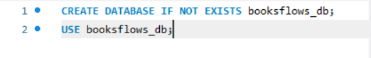
Output:
Query 2:
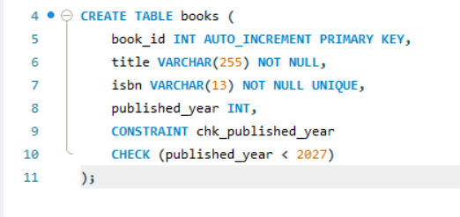
Output:
Query 3:
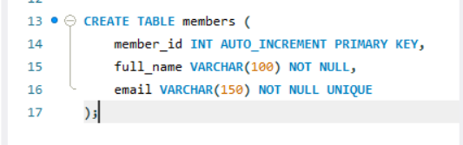
Output:
Query 4:
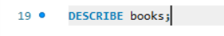
Output:
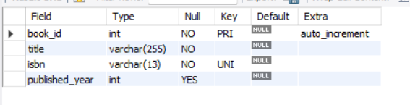
Query 5:
Output:
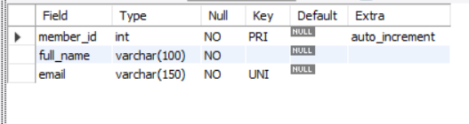
Query 6:
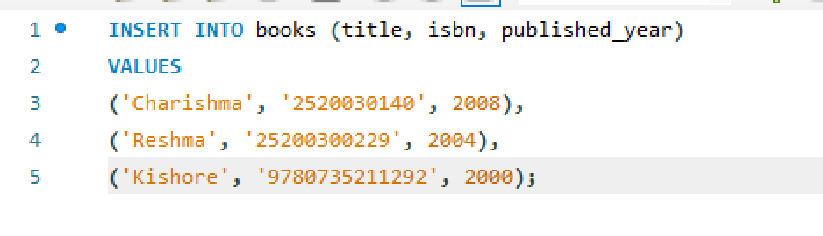
Output:
Query 7:
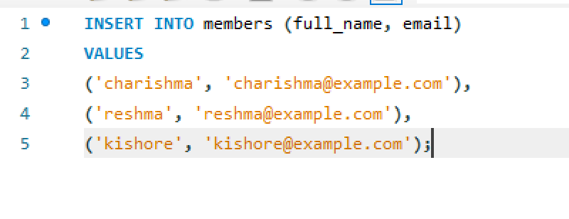
Output:
Query 8:
Output:
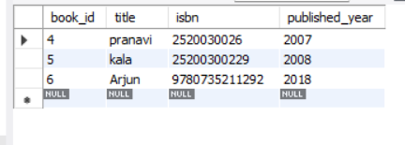
Query 10:
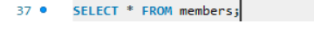
Output:
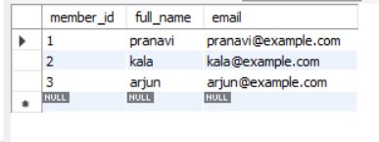
Query 11:
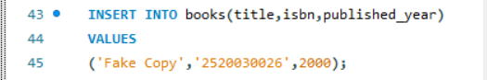
Output:
Query 12:
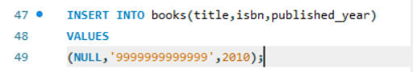
Output:
Query 13:
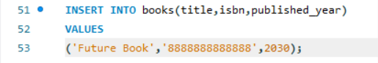’
Output:
Query 14:
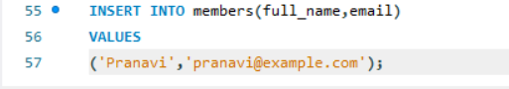
Output:

